Contents

Summary: 1

Printed Circuit Board 1

PCB Parts 3

PCB Stencil 4

# Summary:

This document contains ordering instructions for circuits, parts, etc for the Rioux Chem Control box.

# Printed Circuit Board

The data files needed to order the printed circuit boards in located in the PCB directory. All of the files are zipped into a file called ***RIOUX_CHEM_CONTROL_REVA_2013.09.2013.zip***. This file will be uploaded to the printed circuit board vendor.

1. We will order PCBs from a low cost Asian supplier “Myro”. Register a new account at [www.myropcb.com](http://www.myropcb.com).
2. PCB vendors just need to some information about the PCB and your “gerber” files. The zip file contains these gerb files. We will step through the process of ordering some boards.
3. Select “Online Quote – PCB Full Featured Quote”

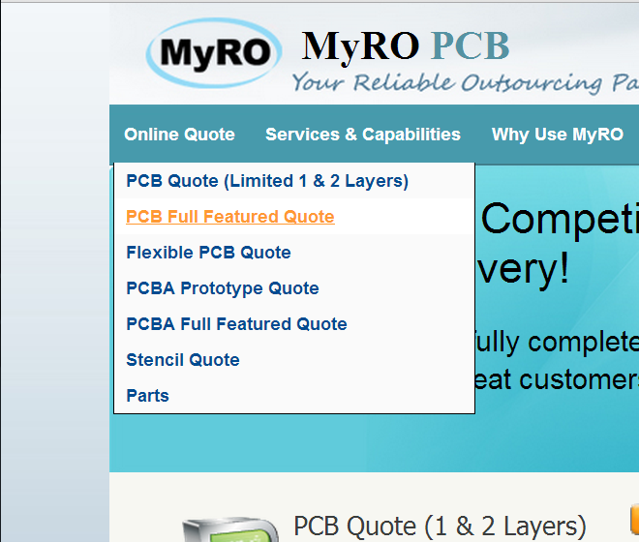

1. Use the parameters shown below. Double check that “finished copper weight” is 2oz.

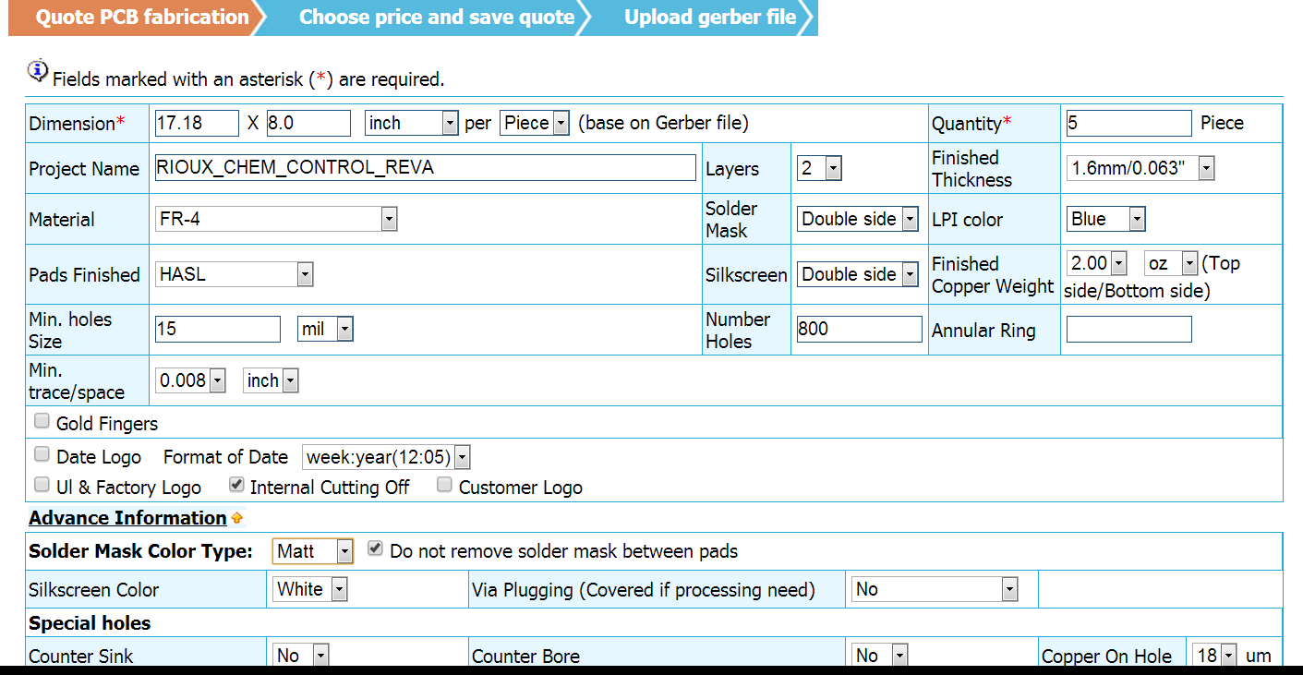

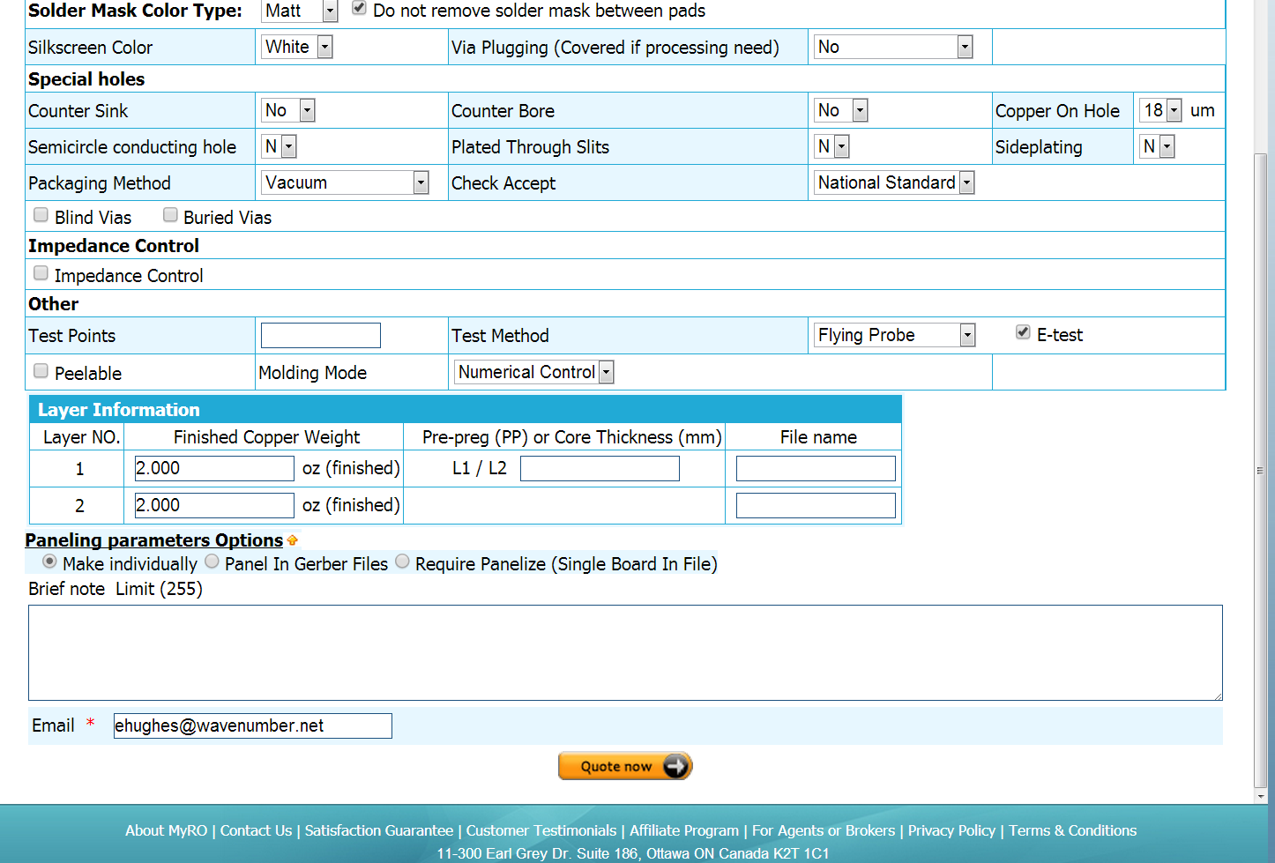

Add this text to the “Brief notes” Section”

“See Readme.txt file in .zip”

This should generate a quote for about $350USD for 5 PCBs.

Follow the instructions to save the quote, upload the zip file and order the boards.

# PCB Parts

See the Excel file “BOM---CHEM_BOX_a_.xls”. This shows the components need to build 1 PCB. Multiply the qtys by the number of boards needed. Some parts maybe need to be ordered in qtys or 10. Note that not all parts are available from Digikey. For example, the inductor L1 must be ordered directly from Coil Craft.

# PCB Stencil

If you have an oven to reflow the SMT parts, a stencil will help. Order a proto stencil from:

<http://www.stencilsunlimited.com/prototype-smt-stencils-p-28.html>

Use the .zip file from the PCB ordering section.

You should also order some solder paste:

<http://www.stencilsunlimited.com/798lf-water-soluble-lead-free-solder-paste-250-gram-jar-p-643.html>